**Data types**

In Java every variable and every expression has some type. Each and every datatype is clearly defined every assignment should be checked by compiler for type compatibility. Because above reasons we can conclude java language is strongly typed programming language.

Java is not considered as pure object oriented programming language because several OOP features are not satisfied by Java. (Like operator overloading, multiple inheritance etc.)

Moreover we are depending on primitive data types which are non objects.

**Primitive Data types**

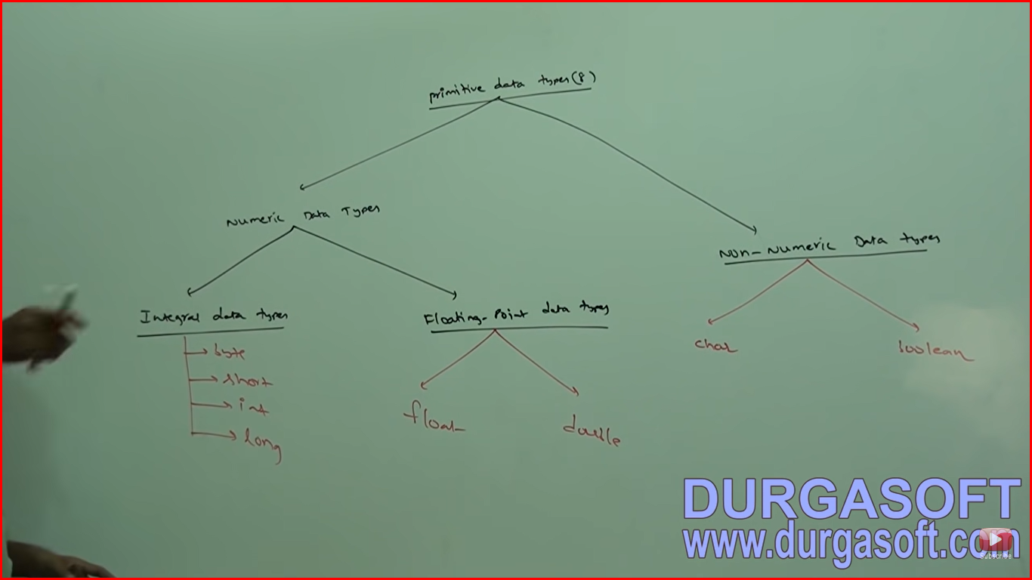

**Except boolean and char, remaining datatypes are considered as signed datatypes because we can represent both the positive and negative numbers.**

**Byte Datatype**

Size of 1 byte = 8 bits

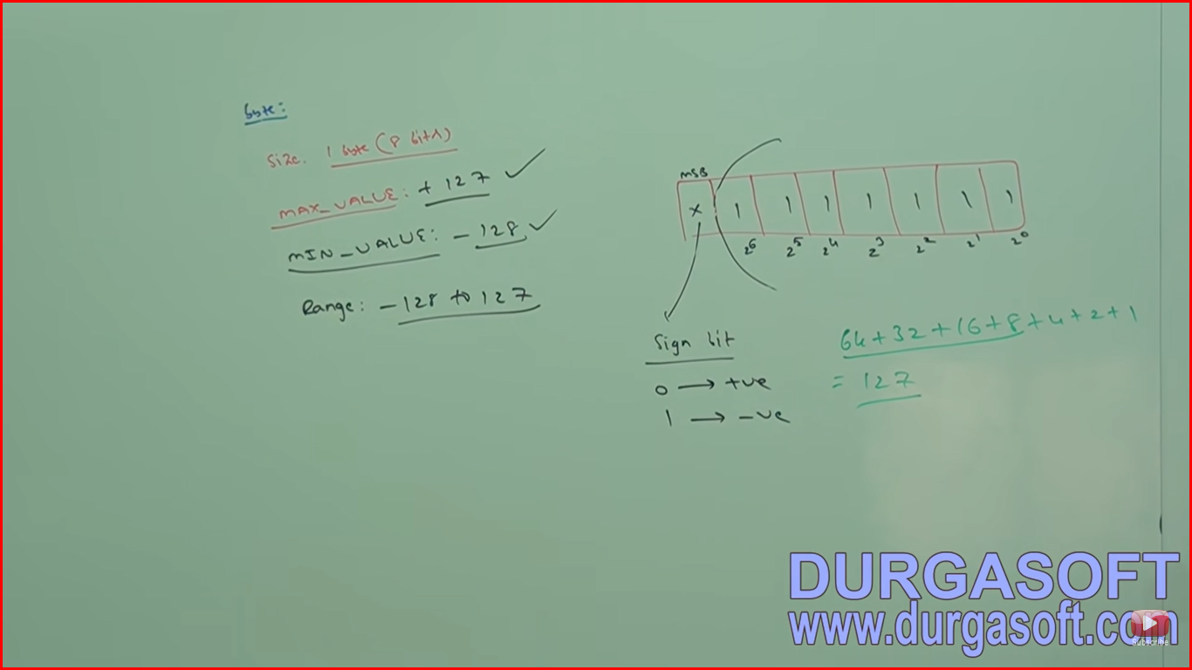

The MSB (Most significant bit) acts as sign bit. 0 means positive number and 1 means negative number. Positive numbers will be represented directly in the memory whereas negative represented in 2’s compliment form.

byte b = 10; - valid

byte b = 127 - valid

byte b = 128 – compile time error

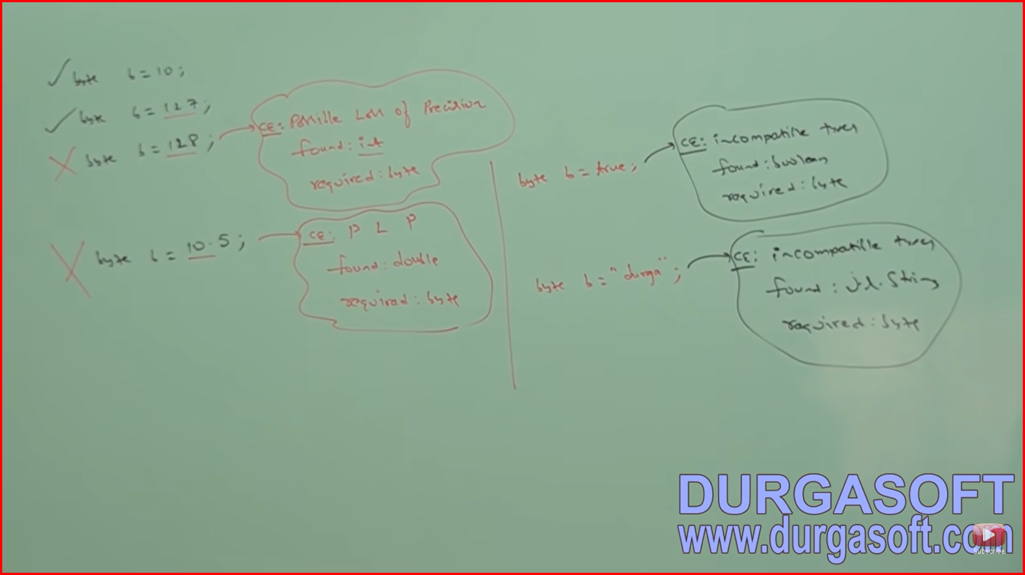

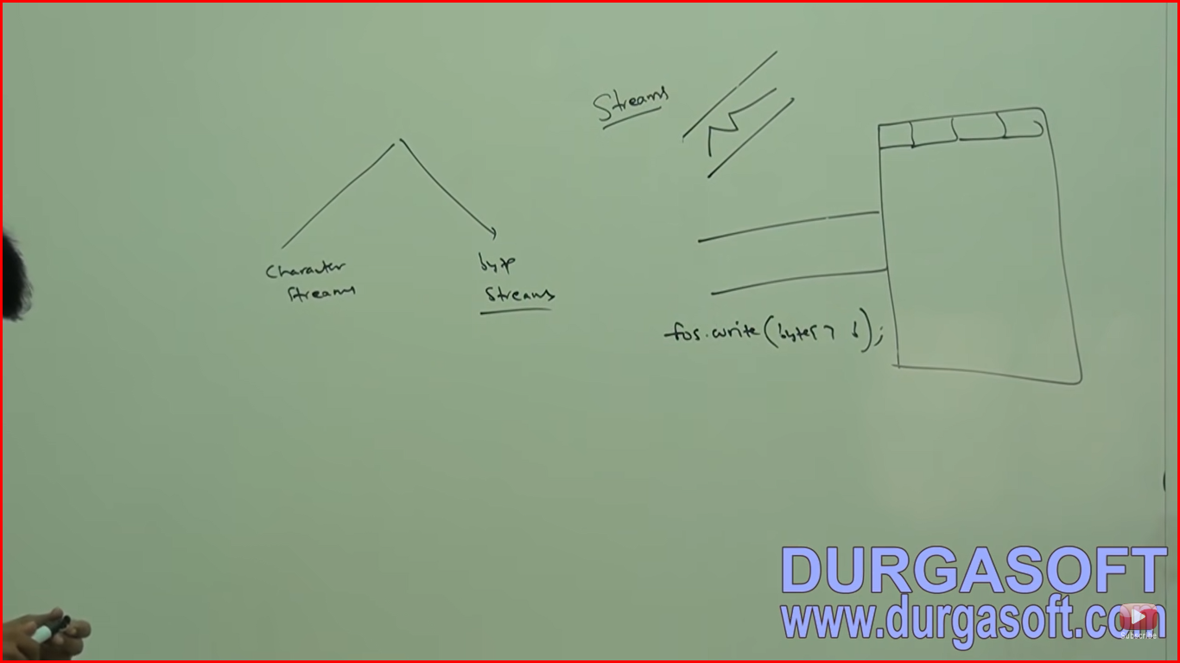

Byte is the best choice if we handle data in terms of streams either from the file or from the network (File supported form or network supported form is byte).

**Short**

This is the most rarely used data type in java.

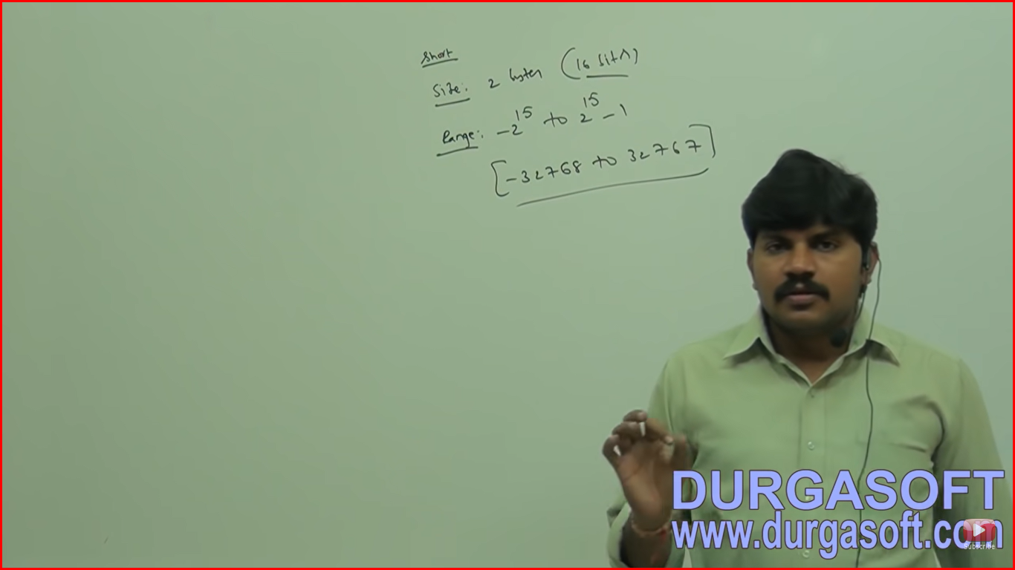

Exception in thread "main" java.lang.Error: Unresolved compilation problem:

Type mismatch: cannot convert from int to short

Short datatype is best suitable for 16 bit processor like 8085 but these processors are completely outdated and hence corresponding short datatype is also outdated datatype.

int dataType

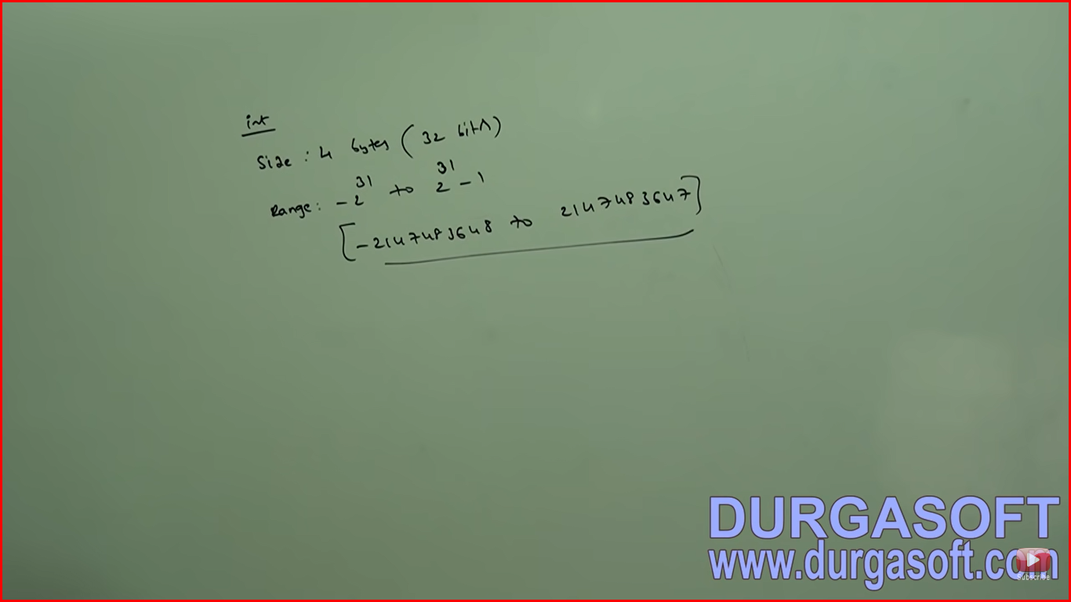

The most commonly used datatype in java is int.

Size : 4 bytes (32 bits)

Range: -2^31 to 2^31-1 [-2147483648 to 2147483647

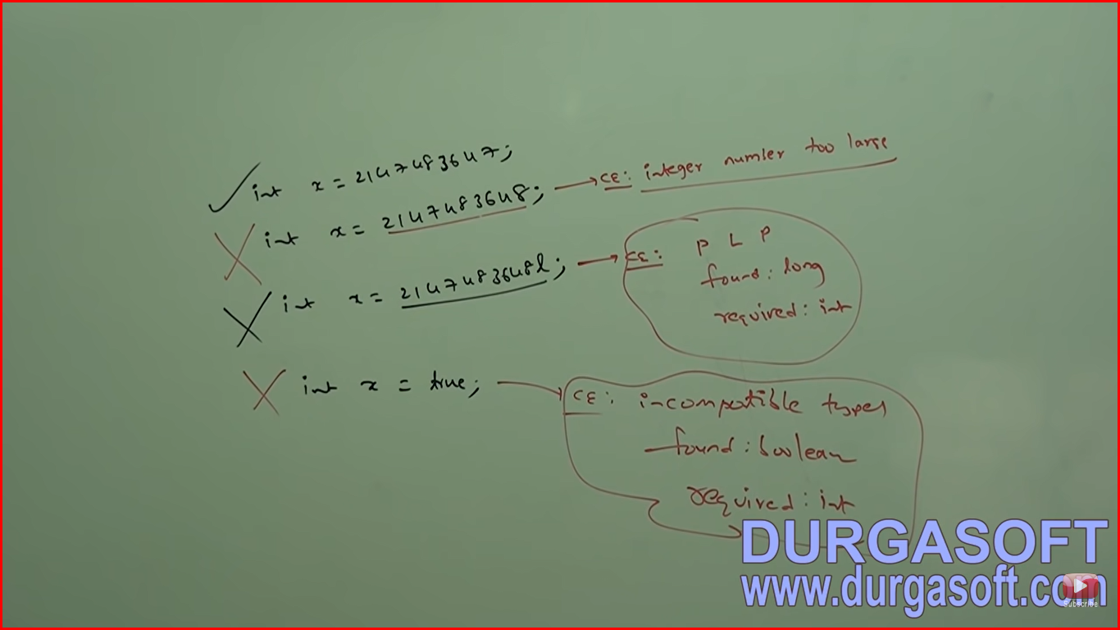

**Long Data type**

Sometimes int may not enough to hold big values then we should go for long type. For eg. The amount of distance travelled by light in 1000 days, to hold these values int may not enough we should go for long data type. Eg long l = 126000*60*24*1000 miles

Ex 2 The number of characters present in a big file may exceed int range hence the return type of length method is long but not int

Long l = f.length();

**Size: 8 byte**

**Range : -2^63 to 2^63-1**

**Note – All the above data types (byte, short, int, long) meant for representing integral values. If we want to represent the floating point values then we should go for floating point data types.**

**Floating point Data types**

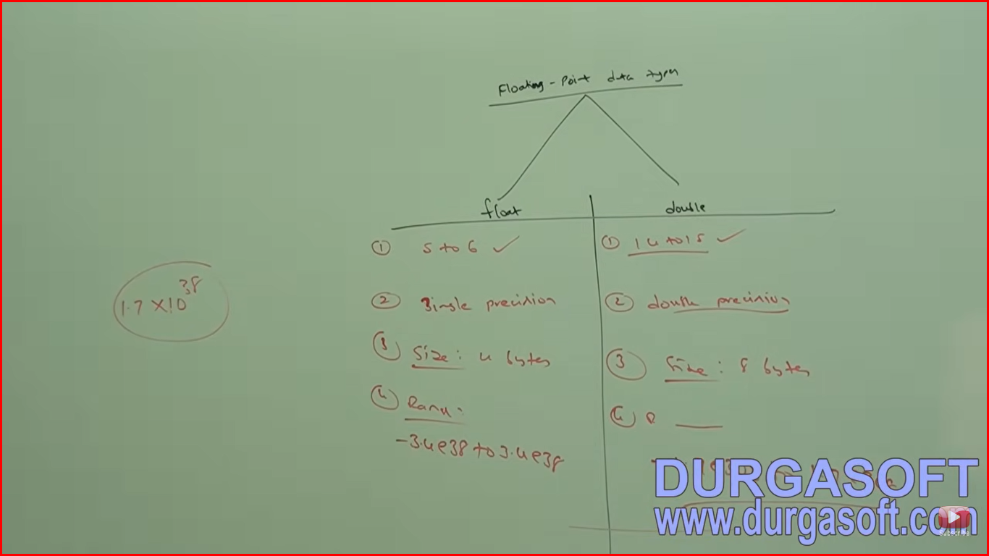

**If we want 5 to 6 decimal places accuracy then we should go for float, If we want 14 to 16 decimal places of accuracy then we should go for double.**

**Float follows single precision and double follows double precision.**

**Size of float is 4 bytes and double is 8 bytes.**

**Range of float is -3.4 e38 to 3.4 e38**

**Range of double: -17.e308 to 1.7 e308**

**Boolean Data type**

Size : NA [JVM dependent sometime 1 bit or 1 bytes]

Range: NA [But allowed values are true or false]

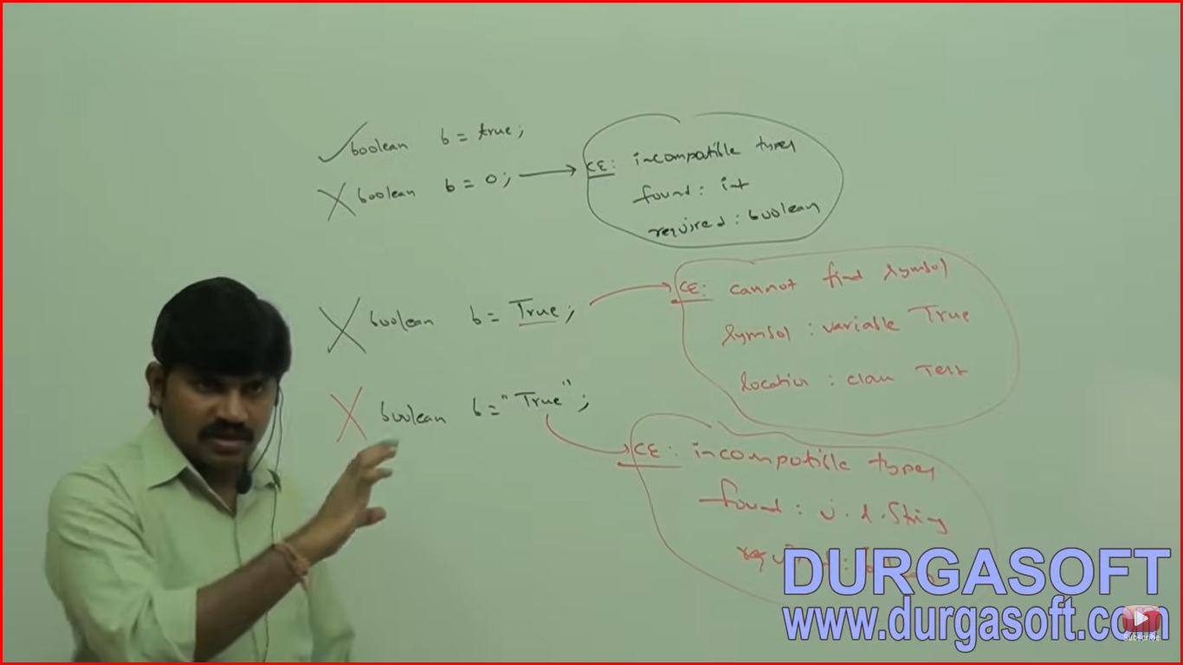

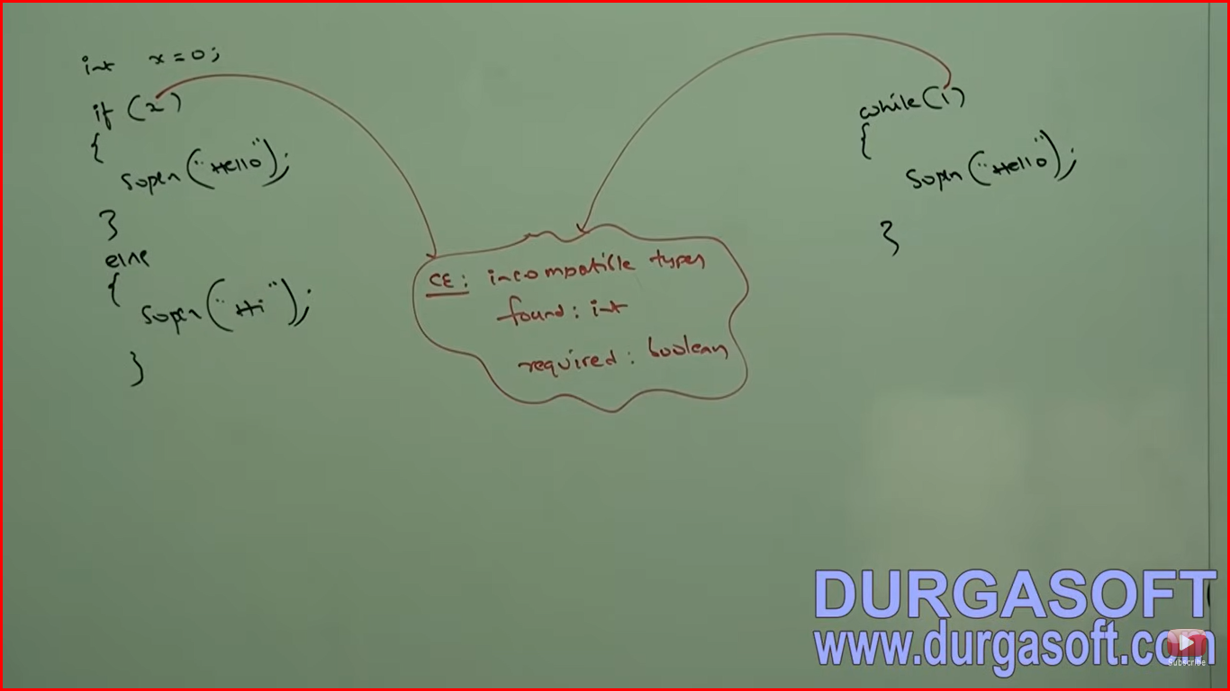

**Char Data Type**

**Size: 2 byte**

Java is Unicode based old language are ASCII based. Old languages like (C, C++) are ASCII code based and the number of different allowed ASCII code characters are less than or equal to <=256. To represent these 256 characters 8 bits are enough hence the size of char in old languages is 1 byte. But Java is Unicode based and the number of different Unicode characters are >256 and less than or equal to <=65536 to represent these many characters 8 bits may not enough compulsory we should go for 16 bits. Hence the size of char in java is 2 bytes.

**Range: 0 to 65535**

**Summary of Java primitive Datatypes**

